Faculty of Information Technology


Assignment 2

Subject: Software Testing
Topic: Automated Testing with Selenium

Lecturer in charge: Vũ Thị Hạnh

Student name: Trương Tấn Đạt
Student ID: 3121411047
Class: DCT121C5

Academic year: 2024 - 2025 / Semester 1

Contents
I. Objective, Purpose 3
II. Application Overview 3
III. Testing Scope 3
IV. Test cases 4
Login Functionality 4
Logout Functionality 5
Navigation Functionality 5
Registration Functionality 6
Search Functionality 8
Add-to-Cart Functionality 9
Checkout Functionality 11
User Support Features 14
V. Test Case Summary Report 15
1. Metrics 15
2. Execution Details 16
3. Type of Testing Performed 16
4. Test Environment and Tools 16
5. Lessons Learnt 17
6. Recommendations 17
7. Best Practices 17
8. Exit Criteria 17
9. Conclusions/Sign Off 17

- Objective, Purpose
Objective
To develop automated test scripts using Selenium for testing web application functionalities, execute these scripts, and generate comprehensive test reports.

Purpose
To ensure the functionality, usability, performance, and security of the clothes and household selling website meet the specified requirements and provide a seamless shopping experience for users.

- Application Overview
The website allows users to browse, search, and purchase a variety of clothing items and household products. Key features include user registration, logging in/out, shopping cart functionality and payment processing.

- Testing Scope
The testing will cover
- User registration and log in/out
- Product search functionality
- Shopping cart functionality
- Add-to-Cart functionality
- Payment gateway integration
- Navigation
- User support features

Out of Scope
- Responsive design across devices
- Security and performance testing

- Test cases

Login Functionality

Test case ID | Description | Steps | Expected Result
TC001 | Test valid login | - Navigate to http://localhost/eCommerceSite-PHP/login.php  - Enter email address  - Enter password  - Click “Submit” | User is logged in, and navigate to the dashboard
TC002 | Test invalid email | - Navigate to http://localhost/eCommerceSite-PHP/login.php  - Enter wrong email address  - Enter password  - Click “Submit” | The website show the error “Email Address does not match.”
TC003 | Test invalid password | - Navigate to http://localhost/eCommerceSite-PHP/login.php  - Enter email address  - Enter wrong password  - Click “Submit” | The website show the error “Passwords do not match.”
TC004 | Test empty fields | - Navigate to http://localhost/eCommerceSite-PHP/login.php  - Click “Submit” | The website show the error “Email and/or Password can not be empty.”
TC005 | Test invalid email | - Navigate to http://localhost/eCommerceSite-PHP/login.php  - Enter invalid email address (an email without an “@”)  - Enter password  - Click “Submit” | The UI show the error message about missing an “@” in email

Logout Functionality

Test case ID | Description | Steps | Expected Result
TC006 | Test logout | - Navigate to http://localhost/eCommerceSite-PHP/login.php  - Enter email address  - Enter pasword  - Click “Submit”  - Click “Logout” | User is logged out and back to the login page

Navigation Functionality

Test case ID | Description | Steps | Expected Result
TC007 | Test the navigation | - Navigate to http://localhost/eCommerceSite-PHP/index.php  ( Check the title and the URL of each page)  - Click “About Us”  - Click “FAQ”  - Click “Contact Us”  - Click “FAQ”  - Click “Home” | The title and URL of each page are completely right

Registration Functionality

Test case ID | Description | Steps | Expected Result
TC008 | Test the navigation | - Navigate to http://localhost/eCommerceSite-PHP/registration.php  - Enter fullname  - Enter company name  - Enter email address  - Enter phone  - Enter address  - Choose country  - Enter city  - Enter state  - Enter zip code  - Enter password  - Retype password  - Click “Register”  (There is a major error about the mail() method in PHP, but it did not affect the execution) | The website show the message “Your registration is completed. Please check your email address to follow the process to confirm your registration.”
TC009 | Test existed email | - Navigate to http://localhost/eCommerceSite-PHP/registration.php  - Fill all required fields and enter an existed email  - Click “Submit” | The website show the error “Email Address Already Exists”
TC010 | Test empty fields | - Navigate to http://localhost/eCommerceSite-PHP/registration.php  - Fill all required fields except the Fullname, Email and Phone  - Click “Submit” | The website show the list of error message about the empty fields
TC011 | Test entering special character in the “Name” field | - Navigate to http://localhost/eCommerceSite-PHP/registration.php  - Fill all required fields and fill the “Name” field with speacial character (example “Dat@!”)  - Click “Submit” | The website should show the error message about the special character must not be contained in Name
TC012 | Test the retype password if it matches the password | - Navigate to http://localhost/eCommerceSite-PHP/registration.php

There is a major error relating to the method “mail()” in PHP. To be more specific, the website was failed to connect to mail server at localhost (SMTP). But it still successfully registered, as administrator can activate that account.

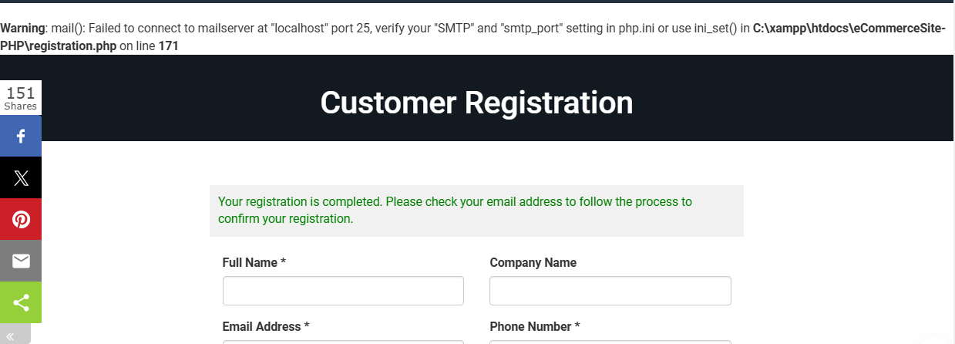

Also, if we input a special character in the “Name” field and fill all required fields, after clicking “Register” the website completely accept the registration requirement. This is a critical error. The error log is on the picture below.

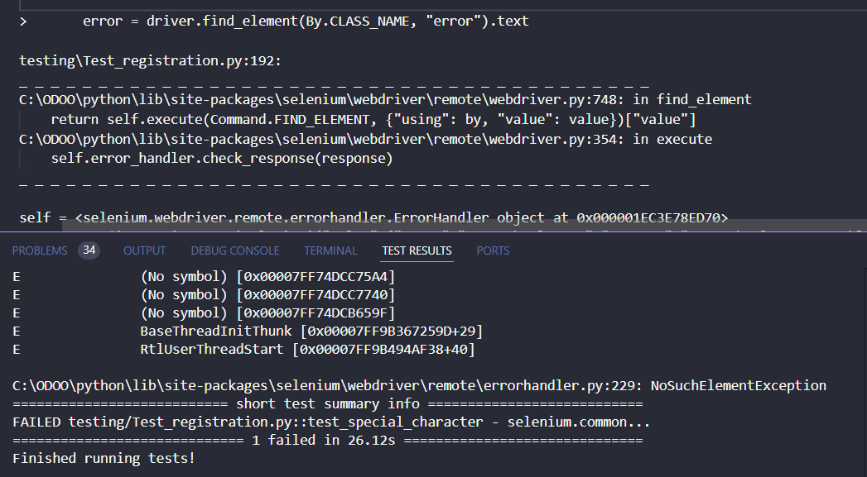

Search Functionality

Test case ID | Description | Steps | Expected Result
TC013 | Test search product and founded that product | - Navigate to http://localhost/eCommerceSite-PHP/index.php  - Enter the keyword “shirt” in the search field  - Click “Search” | The website should show products whose titles contain the keyword
TC014 | Test search product and not founded that product | - Navigate to http://localhost/eCommerceSite-PHP/index.php  - Enter the keyword “agz” in the search field  - Click “Search” | The website should show the label “No result found”
TC015 | Test search space keyword | - Navigate to http://localhost/eCommerceSite-PHP/index.php  - Enter the keyword “ “ in the search field  - Click “Search” | The website should show all products

Add-to-Cart Functionality

Test case ID | Description | Steps | Expected Result
TC016 | Test add a product | - Navigate to http://localhost/eCommerceSite-PHP/login.php  - Enter email address  - Enter password  - Click “Submit”  - Click the category “Men”  - Click the product with the name “Amazfit GTS 3 Smart Watch for Android iPhone”  - Choose color (Optional)  - Click “Add to Cart”  - Click “Cart” | The product in cart must be the same as the product user has added
TC017 | Test remove a product | - Navigate to http://localhost/eCommerceSite-PHP/login.php  - Enter email address  - Enter password  - Click “Submit”  - Click the category “Men”  - Click the product with the name “Amazfit GTS 3 Smart Watch for Android iPhone”  - Click “Add to Cart”  - Click “Cart”  - Click the trash symbol of the product you has added | The website should remove the product you choose from cart
TC018 | Test cart viewing | - Navigate to http://localhost/eCommerceSite-PHP/login.php  - Enter email address  - Enter password  - Click “Cart” | The website should show all products user has added
TC019 | Test increase the quantity of product in cart | - Navigate to http://localhost/eCommerceSite-PHP/login.php  - Enter email address  - Enter password  - Click “Submit”  - Click the category “Men”  - Click the product with the name “Amazfit GTS 3 Smart Watch for Android iPhone”  - Click “Add to Cart”  - Click “Cart”  - Increase the quantity to 4  - Click “Update Cart” | The quantity of the product should be updated in cart
TC020 | Test add more than 1 product | - Navigate to http://localhost/eCommerceSite-PHP/login.php  - Enter email address  - Enter password  - Click “Submit”  - Search random products  - Choose quantity  - Click “Add to Cart” for each product  - Click “Cart” | The name and the quantity of each product in cart is the same as products before user has added.

Checkout Functionality

Test case ID | Description | Steps | Expected Result
TC021 | Test checkout process with the “Bank Deposit” payment method | - Navigate to http://localhost/eCommerceSite-PHP/login.php  - Enter email address  - Enter password  - Click “Submit”  - Click “Update Billing and Shipping Info”  - If that account has not updated the “Billing Address” and “Shipping Address” before, fill all required field  - Click “Update”  - Click the category “Men”  - Click the product with the name “Amazfit GTS 3 Smart Watch for Android iPhone”  - Choose color and quantity (Optional)  - Click “Add to Cart”  - Click “Cart”  - Click “Proceed to Checkout”  - Select Payment Method “Bank Deposit”  - Enter transaction information  - Click “Pay now” | The website should show a successful message about payment
TC022 | Test checkout process with the “PayPal” payment method | - Navigate to http://localhost/eCommerceSite-PHP/login.php  - Enter email address  - Enter password  - Click “Submit”  - Click “Update Billing and Shipping Info”  - If that account has not updated the “Billing Address” and “Shipping Address” before, fill all required field  - Click “Update”  - Click the category “Men”  - Click the product with the name “Amazfit GTS 3 Smart Watch for Android iPhone”  - Choose color and quantity (Optional)  - Click “Add to Cart”  - Click “Cart”  - Click “Proceed to Checkout”  - Select Payment Method “PayPal”  - Enter transaction information  - Click “Pay now” | The website should navigate to PayPal page to complete the payment process

There is a critical error when user checkout with PayPal payment method. To be more specific, when the website navigate to the PayPal page, there is no payment in that page, as user cannot complete the payment process.

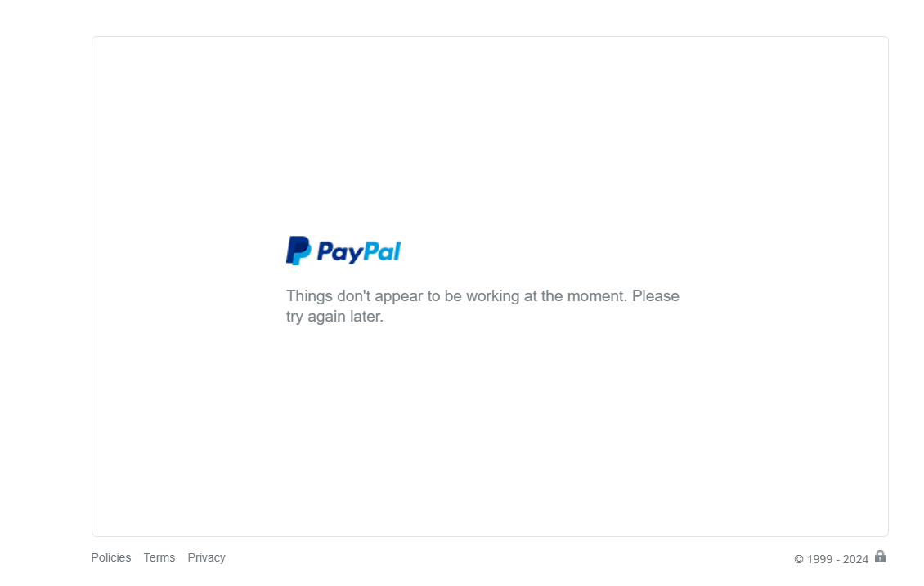

The error log is on the picture below.

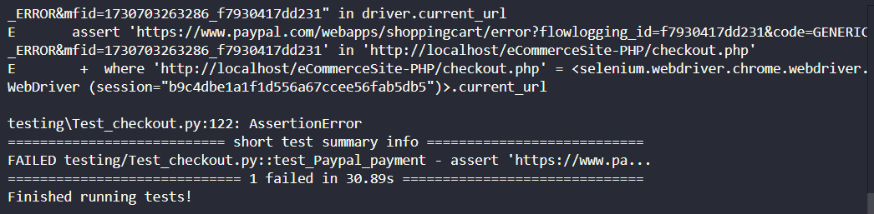

User Support Features

Test case ID | Description | Steps | Expected Result
TC023 | Test the forget password functionality | - Navigate to http://localhost/eCommerceSite-PHP/login.php  - Click “Forget Password?”  - Enter email address  - Click “Submit” | The website should send the  confirmation message to email of user
TC024 | Test the forget password functionality with invalid email | - Navigate to http://localhost/eCommerceSite-PHP/login.php  - Click “Forget Password?”  - Enter invalid email address (an email without an “@”)  - Click “Submit”” | The website should show the UI error message about missing an “@” in email
TC025 | Test the user updating information functionality | - Navigate to http://localhost/eCommerceSite-PHP/login.php  - Enter email address  - Enter password  - Click “Submit”  - Click “Update Profile”  - Choose information you want to update and fill it again  - Click “Update” | The website should show the success updating information message
TC026 | Test updating the "Name" field data, the new value contains a special character | - Navigate to http://localhost/eCommerceSite-PHP/login.php  - Enter email address  - Enter password  - Click “Submit”  - Click “Update Profile”  - Enter a name with special character (example: Dat@!)  - Click “Update” | The website should show the message about name cannot contains special character
TC027 | Test update password functionality | (Chưa xong)
TC028 | Test the retype password if it matches the password | (Chưa xong)

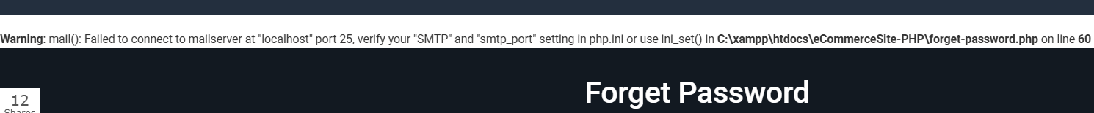

- Test Case Summary Report
- Metrics

Test cases Planned | Test cases Executed | Test cases Passed | Test cases Failed
28 | 25 | 22 | 3

- Execution Details
- Execution Time
- Error Details

- Type of Testing Performed
Functional Testing
Functional Testing is carried out to verify that each function of the application operates according to the specified requirements. This includes testing all primary features of the website, such as:
- User registration and login/out.
- Product search and filtering.
- Shopping cart operations (adding, removing items, …).
- Payment processing through the payment gateway.
- User support features, such as password recovery and account information updates.

- Test Environment and Tools
Testing Environment
- IDE: Visual Studio Code
- Localhost

Tools
- Selenium Web Driver for automated functional testing
- Chrome Driver
- Xampp

Application URL | http://localhost/eCommerceSite-PHP
Apps Server | 127.0.0.1
Database | MySQL

- Lessons Learnt
- Recommendations
- Best Practices
- Exit Criteria
- Conclusions/Sign Off
As the Exit criteria was met and satisfied as mentioned in Section 10, this application is suggested to ‘Go Live’ by the Testing team. Appropriate User/Business acceptance
testing should be performed before ‘Go Live’.

